Ex1
import cv2
import matplotlib.pyplot as plt
from google.colab import files
import numpy as np

uploaded = files.upload()
filename = next(iter(uploaded))
img = cv2.imdecode(np.frombuffer(uploaded[filename], np.uint8), cv2.IMREAD_COLOR)

if img is None:
raise ValueError("Unable to read the uploaded image.")

gray = cv2.cvtColor(img, cv2.COLOR_BGR2GRAY)

plt.figure(figsize=(10, 4))
plt.subplot(1, 2, 1)
plt.imshow(cv2.cvtColor(img, cv2.COLOR_BGR2RGB))
plt.title("Original Image")
plt.axis("off")

plt.subplot(1, 2, 2)
plt.imshow(gray, cmap="gray")
plt.title("Grayscale Image")
plt.axis("off")
plt.show()


Ex2
import cv2
import matplotlib.pyplot as plt
from google.colab import files
import numpy as np
uploaded = files.upload()
filename = next(iter(uploaded))
img = cv2.imdecode(np.frombuffer(uploaded[filename], np.uint8), cv2.IMREAD_COLOR)
if img is None:
raise ValueError("Unable to read image.")
blurred = cv2.GaussianBlur(img, (15, 15), 0)
plt.figure(figsize=(10, 4))
plt.subplot(1, 2, 1)
plt.imshow(cv2.cvtColor(img, cv2.COLOR_BGR2RGB))
plt.title("Original Image")
plt.axis("off")
plt.subplot(1, 2, 2)
plt.imshow(cv2.cvtColor(blurred, cv2.COLOR_BGR2RGB))
plt.title("Gaussian Blur")
plt.axis("off") plt.show()


Ex3
import cv2
import matplotlib.pyplot as plt
from google.colab import files
import numpy as np
uploaded = files.upload()
filename = next(iter(uploaded))
img = cv2.imdecode(np.frombuffer(uploaded[filename], np.uint8), cv2.IMREAD_COLOR)
if img is None:
raise ValueError("Unable to read image.")
gray = cv2.cvtColor(img, cv2.COLOR_BGR2GRAY)
edges = cv2.Canny(gray, 100, 200)
plt.figure(figsize=(10, 4))
plt.subplot(1, 2, 1)
plt.imshow(cv2.cvtColor(img, cv2.COLOR_BGR2RGB))
plt.title("Original Image")
plt.axis("off")
plt.subplot(1, 2, 2)
plt.imshow(edges, cmap="gray")
plt.title("Canny Edges")
plt.axis("off") plt.show()
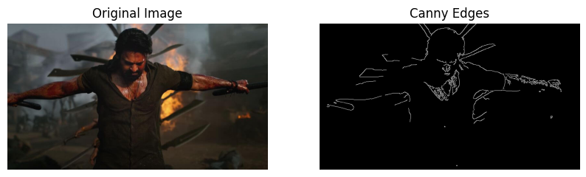
Ex4
import cv2
import matplotlib.pyplot as plt
from google.colab import files
import numpy as np
uploaded = files.upload()
filename = next(iter(uploaded))
img = cv2.imdecode(np.frombuffer(uploaded[filename], np.uint8), cv2.IMREAD_COLOR)
if img is None:
raise ValueError("Unable to read image.")
gray = cv2.cvtColor(img, cv2.COLOR_BGR2GRAY)
equalized = cv2.equalizeHist(gray)
plt.figure(figsize=(12, 7))
plt.subplot(2, 2, 1)
plt.imshow(gray, cmap="gray")
plt.title("Original Grayscale")
plt.axis("off")
plt.subplot(2, 2, 2)
plt.imshow(equalized, cmap="gray")
plt.title("Histogram Equalized")
plt.axis("off")
plt.subplot(2, 2, 3)
plt.hist(gray.ravel(), 256, [0, 256])
plt.title("Original Histogram")
plt.subplot(2, 2, 4)
plt.hist(equalized.ravel(), 256, [0, 256])
plt.title("Equalized Histogram")
plt.tight_layout()
plt.show()
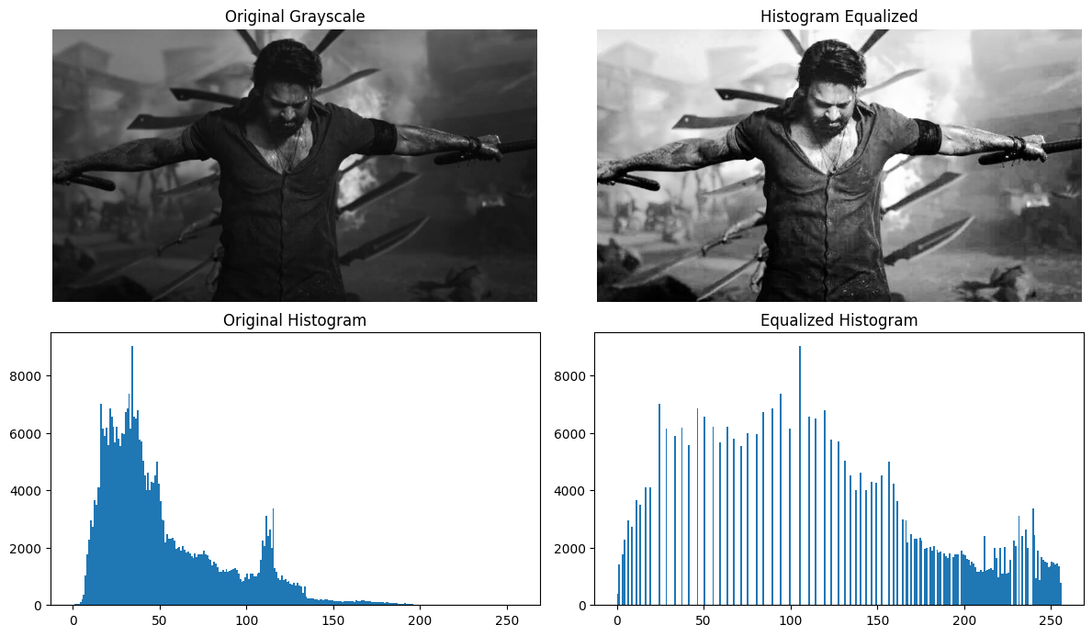

Ex5
import cv2
import matplotlib.pyplot as plt
from google.colab import files
import numpy as np
def analyze_histogram(img):
colors = ("b", "g", "r")
names = ("Blue", "Green", "Red")
for i, color in enumerate(colors):
hist = cv2.calcHist([img], [i], None, [256], [0, 256])
plt.plot(hist, color=color, label=names[i])
plt.title("Color Channel Histogram")
plt.xlabel("Pixel Intensity (0–255)")
plt.ylabel("Number of Pixels")
plt.legend()
plt.show()
uploaded = files.upload()
filename = next(iter(uploaded))
img = cv2.imdecode(np.frombuffer(uploaded[filename], np.uint8), cv2.IMREAD_COLOR)
if img is None:
raise ValueError("Unable to read image.")
analyze_histogram(img)
